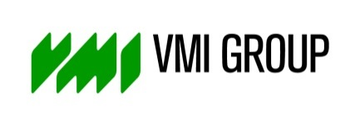

PRESS RELEASE

October 9th, 2018

VMI participates in Science Weekend

On Saturday 6 October, VMI offered around 100 visitors a glimpse behind the scenes as part of the Science Weekend.
A demonstration of a tire building machine was definitely the highlight of the company tour. The younger guests in particular were very fascinated while watching how car tires are produced. They also had the opportunity to create their own work pieces and tried the challenging robot basket.
VMI is eager to give young people a chance to discover the broad range of prospects that the technical professions have to offer. The Science Weekend proved to be a fantastic opportunity for VMI to get young people interested in technology. Over the course of this weekend, companies, institutes, universities, agencies and museums at over 350 locations throughout the Netherlands opened their doors to the public.

/////////////////////////////////////////////////////////
For further information please contact:
Judith Koops
Manager Communications
T +31 (0) 578 67 97 18
M +31 (0) 6 23 05 10 48
jkoops@vmi-group.com

About VMI

VMI is a wholly owned subsidiary of TKH Group N.V. (NYSE Euronext Amsterdam, www.tkhgroup.com). VMI develops, manufactures, sells and installs high tech machines for the tire, rubber, can, personal care and pharmaceutical industry and offers global technical support from service centers in The Netherlands, Germany, Poland, USA, Brazil, China, Malaysia and Russia. VMI employs more than 1600 people around the world. To learn more about VMI Group, please visit www.vmi-group.com.

